**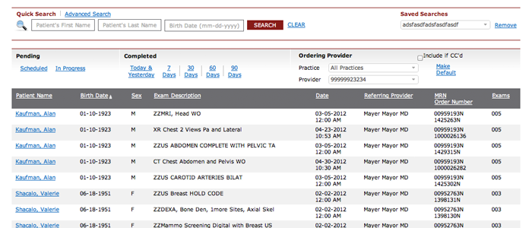**

**Main Page**

By default, the main page shows you all your patients with completed exams within the previous 30 days. You can change this default display, if you wish.

Macintosh HD:Users:Ziggy:Desktop:Project Directory:201 Marketing Support:RadNet:Physician Portal:learnmore_main_highlight.png

Filter results by common date ranges or exam statuses. The highlighted item signals the current filter.

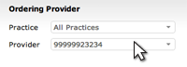

Broaden your search by selecting other practices or multiple providers.

Macintosh HD:Users:Ziggy:Desktop:Project Directory:201 Marketing Support:RadNet:Physician Portal:learnmore_main_clickname.png

Click on the patient name to go to the Patient Detail Page to review reports and images.

**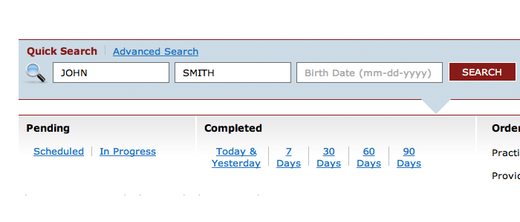**

**Quick Search**

Quick Search allows you to search on the most common patient attributes—name and birth date. Quick Search only searches for your patients, or patients of physicians within your practice.

Macintosh HD:Users:Ziggy:Desktop:Project Directory:201 Marketing Support:RadNet:Physician Portal:learnmore_quicksearch_clickbutton.png

Click the Search Button to complete a Quick Search. Not all fields are required. Click the Clear Link to remove the Quick Search query and return to the default display results.

The background changes to light blue when a Quick Search query is controlling the display results.

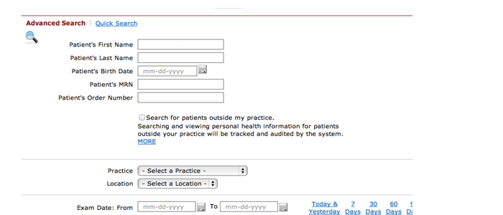

**Advanced Search**

Advanced search offers a broader set of attributes to find patients.

Macintosh HD:Users:Ziggy:Desktop:Project Directory:201 Marketing Support:RadNet:Physician Portal:learnmore_advancedsearch_searchoutside.png

By default, the portal only shows your patients and patients of other providers in your practice. However, you can broaden a search to include patients outside of your practice.

Macintosh HD:Users:Ziggy:Desktop:Project Directory:201 Marketing Support:RadNet:Physician Portal:learnmore_quicksearch_clickbutton.png

Click the Search Button to complete the search. Not all fields are required. Click the Clear Link to remove the search query and return to the default display results.

**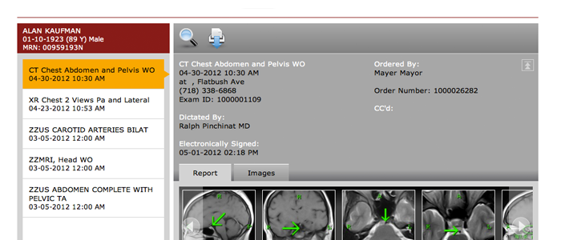**

**Patient Detail Page**

The Patient Detail Page shows the complete exam history for the patient. Selecting an exam will provide access to the report and images for that exam.

Macintosh HD:Users:Ziggy:Desktop:Project Directory:201 Marketing Support:RadNet:Physician Portal:learnmore_patientdetail_selectedpatient.png

Shows the selected patient, with demographic details. When available, we’ll display your MRN number for the selected patient.

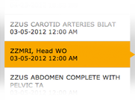

Shows the complete exam history for the select patient—sorting the most recent exams at the top and older exam descending to the bottom.

Macintosh HD:Users:Ziggy:Desktop:Project Directory:201 Marketing Support:RadNet:Physician Portal:learnmore_patientdetail_reportimagetab.png

Click the Report Tab to view the exam’s report. Click the Images Tab to view the exam’s images.

Macintosh HD:Users:Ziggy:Desktop:Project Directory:201 Marketing Support:RadNet:Physician Portal:learnmore_patientdetail_searchicon.png

Click the Search Icon to return to the search pages.

Macintosh HD:Users:Ziggy:Desktop:Project Directory:201 Marketing Support:RadNet:Physician Portal:learnmore_patientdetail_printicon.png

Click the Dowload Icon to download a PDF of the report.